RESEARCH ARTICLE |  | OPEN ACCESS

Automated Retinal Disease Classification from OCT Images Using a Lightweight CNN–SE Architecture

Parth R. Dave¹., Nikunj H. Domadiya², and Jaiwal Patel³

¹ Research Scholar, Gujarat Technological University, Ahmedabad, Gujarat, India
^{1,2} Assistant Professor, Computer Engineering Department, L. D. College of Engineering, Ahmedabad, Gujarat, India
³ Gems New Millenium School, Dubai
Corresponding author: Nikunj H. Domadiya (e-mail: domadiyanikunj002@gmail.com), Author(s) Email: Parth R. Dave (e-mail: parthdave.ce@ldce.ac.in) Jaiwal Patel (e-mail: ujaiwal@outlook.com)
Abstract Automated classification of retinal diseases from Optical Coherence Tomography (OCT) images can support timely and consistent identification of retinal abnormalities; however, many existing approaches rely on computationally intensive architectures or complex preprocessing procedures. This study proposes a lightweight Convolutional Neural Network with Squeeze-and-Excitation blocks (CNN–SE) for automated multi-class retinal disease classification while maintaining a compact computational structure. The proposed architecture consists of 13 convolutional layers with SE-based channel recalibration, global average pooling, a fully connected layer, and dropout. Unlike approaches that depend on pretrained backbones or multi-stage segmentation, the proposed framework integrates channel-wise feature recalibration directly into a compact CNN, allowing the model to learn discriminative retinal representations with limited architectural complexity. Data augmentation was applied only to the training images, and the network was optimized using the Adam optimizer. The model was evaluated on the eight-class OCT-C8 dataset and the four-class OCT2017 dataset using accuracy, precision, recall, F1-score, and macro-ROC-AUC. The proposed model achieved 97.00% accuracy on OCT-C8 and 99.00% on OCT2017. To assess domain generalization, the model was trained exclusively on OCT-C8 and directly evaluated on the independent OCT2017 test set without retraining or fine-tuning. Across five random seeds, the cross-dataset evaluation achieved 98.74 ± 0.11% accuracy, with consistently high precision, recall, F1-score, and macro-ROC-AUC. The proposed network maintains a compact computational footprint and enables efficient image inference compared with the evaluated lightweight architectures. These results demonstrate that the proposed CNN–SE architecture provides strong classification performance and cross-dataset generalization while maintaining computational efficiency, making it a promising lightweight framework for automated retinal OCT image analysis.
Keywords Convolutional Neural Network; Artificial Intelligence; Machine Learning; Deep Learning; Optical Coherence Tomography
- Introduction
Optical Coherence Tomography (OCT) is a valuable imaging technique used for the early detection of retinal diseases. It generates high-resolution tomographic images of retinal tissue that enables accurate detection of structural abnormalities within the retina part and macula part. Retinal diseases sometimes may result into irreversible vision loss and therefor the early detection of the abnormalities is essential. Retinal OCT imaging is widely used in ophthalmology to assist in treatment planning and to monitor the success of treatments such as laser therapy, eye injections, and surgical interventions. There are several factors that can lead to retinal disorders, such as genetic defects, stress, aging, lack of physical activity, excessive screen exposure, and unhealthy eating habits. As a result, retinal diseases are becoming more common, making it essential to carry out fast, precise, and consistent evaluations. Automated retinal OCT image classification techniques can be helpful as a suggestive system to the doctors which provide impartial, reliable and diagnostic consistencies for pointing out the abnormalities.
Conventional machine learning algorithms use texture-based detailing retrieved from images to represent local or global information. Various feature extraction techniques such as Local Binary Pattern (LBP)[1] , Histogram of Oriented Gradients (HOG)[2], Gray-Level Co-Occurrence Matrix (GLCM)[3] , edge detection, and shape detection are applied to obtain a discriminative feature vector. The extracted feature representation is then fed into supervised learning classifiers, including Artificial Neural Networks (ANN)[4] and Support Vector Machines (SVM) [5], or other classifiers to perform the final image classification. However, one major limitation of classical machine learning approaches is that they depend on manually extracted features instead of learning the features directly from the data. Since the image representation relies only on predefined feature descriptors, some important information from the original image may be lost during the feature extraction process. This loss of information can affect how well the model understands the data and may lead to lower accuracy and reduced overall performance of the classification system.
Deep learning has increasingly become the preferred approach for automated OCT image classification because CNNs[6] can learn discriminative representations directly from retinal image data. Recent studies have explored layer-guided CNNs, segmentation-assisted architectures, transfer learning, ensemble models, and other specialized frameworks to improve classification performance. Although these approaches have demonstrated strong results, their increased architectural depth, dependence on additional preprocessing stages, or reliance on multiple models can introduce greater computational and implementation complexity.
CNNs learn important spatial characteristics and structural relationships in input images by employing successive convolutional and pooling layers. As the data passes through these consecutive layers, increasingly relevant features are extracted and subsequently forwarded to the dense layers where the ultimate classification decision is generated. The fully connected part may consist of multiple hidden units just before reaching to the final output stage. The last layer consists of output nodes representing the different categories defined in the dataset for classification which is enabling the model to accurately assign the input sample to its corresponding category. Appropriate activation functions, model parameters, and hyperparameters are chosen to enhance the learning performance of the network and enhance its generalization capability and robustness on unseen test dataset. In addition to that several techniques are employed to manage problems such as underfitting and overfitting. These methods enable the model to learn efficiently from the training data while ensuring consistent performance when testified on the test dataset.
Within retinal OCT analysis, pretrained and transfer-learning-based architectures such as NASNetMobile [7], AlexNet [8], VGG16 [9], VGG19[9], ResNet50[10], and GoogLeNet [11], have achieved competitive classification performance, but their relatively large parameter counts and computational requirements may limit their suitability for resource-constrained deployment. Other methods incorporate retinal-layer segmentation, region-of-interest extraction, image alignment, or ensemble learning to improve feature discrimination. While such strategies can enhance predictive performance, they also introduce additional processing stages and implementation overhead. These observations motivate the development of a compact architecture that can learn disease-relevant representations directly from OCT images without depending on complex preprocessing or large pretrained backbones.
Automated OCT image analysis plays a crucial role as a suggestive system between patient and a doctor to identify the anomalies in a grater detailed manner. Many efforts have been carried out over the years to achieve this by applying conventional and contemporary machine learning algorithms with various techniques.
P. P. Srinivasan et al. [12] performed image reshaping, noise reduction and cropping the retinal images to extract Histogram of Oriented Gradients (HOG) descriptors [2]. For multi-class classification, a Support Vector Machine (SVM) classifier [5] was used with a one-versus-one strategy, resulting in three linear SVM classifiers corresponding to the three dataset classes: AMD, DME and Normal. The retinal image dataset used in the study was locally developed using OCT images collected from patients with different retinal disorders. Y.-Y. Liu et al. [13] presented proposed a traditional OCT image classification method using multi-resolution and PCA-based[14] LBP features. An SVM classifier was employed to classify MH, ME, and AMD from a locally collected dataset. Alsaih K et al. [15] proposed a conventional OCT classification approach using Histogram of Oriented Gradients (HOG) [2] and Local Binary Patterns (LBP) [1] features with PCA for feature reduction. The optimized features were classified using an Support Vector Machine (SVM) [5] on a locally collected dataset.
On the other hand, several advanced techniques have been proposed for the classification of retinal OCT images. L. Huang et al[16] developed a layer-based CNN that learned features from individual retinal layers for OCT image classification. The extracted features were combined using transfer learning, achieving improved performance on the OCT2017 [17] and HUCM [16] OCT image datasets. J. Kim and L. Tran [18] proposed a two-stage deep learning model for OCT image classification. U-Net-based ROI extraction and image alignment enhanced feature learning, leading to better accuracy than L. Huang et al. [16] on OCT2017 [17] dataset. Shengyong Diao et al. [19] proposed CM-CNN and CAM-UNet for AMD classification from OCT images. Their approach improved region localization and achieved promising performance. Hassan E. et al. [20] proposed the EOCT framework, combining ResNet-50 [10] feature extraction with a Random Forest classifier for OCT image classification. The model, trained using SGD and Adam, achieved state-of-the-art performance. On OCT2017 dataset [17]. For the automatic categorization of normal and AMD retinal scans, Lee [21] suggested a 21-layer VGG16-based convolutional neural network trained on 2.6 million EMR-linked OCT pictures. By combining scan-level predictions, the model attained 87.63\% image-level, 88.98\% OCT-level, and 93.45\% patient-level accuracy (AUROC up to 97.46\%). Nevertheless, the framework's clinical generalizability was constrained by its binary classification capability, lack of external validation, and training using data from a single institution and OCT instrument.
In [22], authors proposed OCTx, an ensemble deep learning model for four-class OCT image classification. It achieved strong performance but was evaluated on a limited dataset. In [23], the authors presented a CNN model using ImageNet pre-trained weights for three-class retinal OCT image classification. Fine-tuning and ensemble learning increased the classification accuracy from 68.17% to 92.89%. In [24], the authors evaluated AlexNet, VGG, Inception, and ResNet for retinal OCT image classification. The Inception model with RMSprop achieved the best results, reaching 95.53% accuracy and an F1-score of 0.93687. In [25], the authors applied NasNetMobile [7] to classify eight retinal diseases using the OCT-C8[26] dataset. Among the tested optimizers, SGD delivered the best results with 97% accuracy and stable convergence within 22 epochs.
Jannat et al. [27] presented OCT-SelfNet is a SwinV2-based self-supervised framework that combines masked autoencoder pre-training with cross-dataset data fusion, achieving 99% classification accuracy with high AUC-ROC, AUC-PR, and F1-score. However, its evaluation is limited to binary classification (AMD vs. Normal), restricting its applicability to multi-class retinal disease diagnosis. Dave and Domadiya et al. [28] formulated a CNN-based model for retinal OCT image classification. Using hybrid pooling, data augmentation, and learning rate decay, the model achieved 98.75% accuracy on the OCT2017 [17] dataset. A thorough analysis of earlier machine learning and deep learning approaches used for OCT image classification is summarized in Table 1.
Despite recent progress in OCT classification, a trade-off remains between predictive performance and model complexity. Layer-guided and segmentation-based methods require additional processing, while transfer-learning and ensemble approaches increase computational and memory demands. Moreover, evaluations are often limited to single datasets or specific disease categories, leaving cross-dataset robustness insufficiently explored. These limitations motivate a compact CNN architecture that combines effective feature selection with computational efficiency across multiple OCT datasets.
To address this gap, this study proposes a lightweight CNN-based model for retinal OCT image classification using the OCT-C8 [26] and OCT2017 [17] datasets. The proposed architecture integrates Squeeze-and-Excitation (SE) blocks within a compact 13-layer CNN to enhance channel-wise feature representation, together with global average pooling and dropout for efficient feature learning and improved generalization. Unlike approaches that rely on pretrained backbones with additional SE modules, the proposed network incorporates channel-wise feature recalibration directly into the CNN architecture, while data augmentation and the Adam optimizer support robust and stable training. The model contains approximately 375,000 trainable parameters, maintaining a compact structure while retaining the capacity to learn diagnostically relevant retinal features. Its effectiveness is assessed through within-dataset classification, cross-dataset validation, ablation experiments, and computational-efficiency analysis, providing a comprehensive evaluation of both predictive performance and model efficiency.
The remainder of this manuscript is organized as follows. Section II presents the proposed methodology, including data preparation, augmentation, SE blocks, optimization, and CNN architecture. Section III describes the experimental setup and discusses the classification, cross-dataset validation, computational-efficiency, ablation, comparative, and explainability results. Section IV concludes the study and discusses its limitations and future research directions.

Method
The detailed architecture of the proposed framework is shown in Fig. 1. The proposed framework mainly has five working modules. The first one is the input datasets, secondly the preprocessing and augmentation, thirdly a CNN architecture with SE blocks, the second last module is selecting a proper optimizer for the multiclass classification and the last one is the evaluation of the model using two different datasets.

Table 1:Overview of Existing Approaches for Retinal OCT Image Classification
Reference | Category | Dataset Used | Key Methodology | Limitation
Y.-Y. Liu et al. [13] | Machine Learning | Local dataset | SVM classifier using both global and local image features | Classification performance is highly dependent on accurate feature extraction and image alignment.
Alsaih K et al. [15] | Machine Learning | Local dataset | HOG, LBP, and PCA features combined with an SVM classifier | Relies on handcrafted feature engineering, which may reduce adaptability to diverse datasets.
L. Huang et al. [16] | Deep Learning | OCT2017, HUCM | Layer-guided CNN developed using transfer learning | Requires retinal layer segmentation before classification, increasing preprocessing complexity.
J. Kim and L. Tran [18] | Deep Learning | OCT2017 | U-Net-based preprocessing with image rotation followed by binary CNN classifiers | Multiple preprocessing stages increase computational complexity and execution time.
S. Diao et al. [19] | Deep Learning | Not specified | CM-CNN integrated with CAM-Unet for retinal image analysis | Separate segmentation and classification networks make the framework more complex.
Hassan E et al. [20] | Hybrid Learning | OCT2017 | ResNet-50 used for feature extraction followed by a Random Forest classifier (EOCT) | Hybrid architecture requires additional training effort and higher implementation complexity.
D. Paul et al. [22] | Ensemble Deep Learning | OCTx, OCT2017 | Ensemble of multiple deep learning models for retinal OCT classification | Limited training data may restrict the model's ability to generalize to unseen clinical images.
Yang J et al. [23] | CNN Ensemble | OCT2017 | Ensemble learning strategy combining multiple CNN models | Increased memory usage and computational requirements during training and inference.
Stanojević et al. [24] | Deep Learning | OCT2017 | Comparative evaluation of CNN models with InceptionV1 showing the best performance | High computational demand limits its suitability for real-time applications.
Madhumithaa S et al. [25] | Deep Learning | OCT-C8 | NasNetMobile architecture optimized using the SGD optimizer | Computationally demanding, making deployment on resource-limited systems challenging.
Dave and Domadiya et al. [28] | Deep Learning | OCT2017 | CNN architecture incorporating hybrid pooling with an optimized training strategy | Validation was limited to four retinal disease categories, reducing its broader applicability.

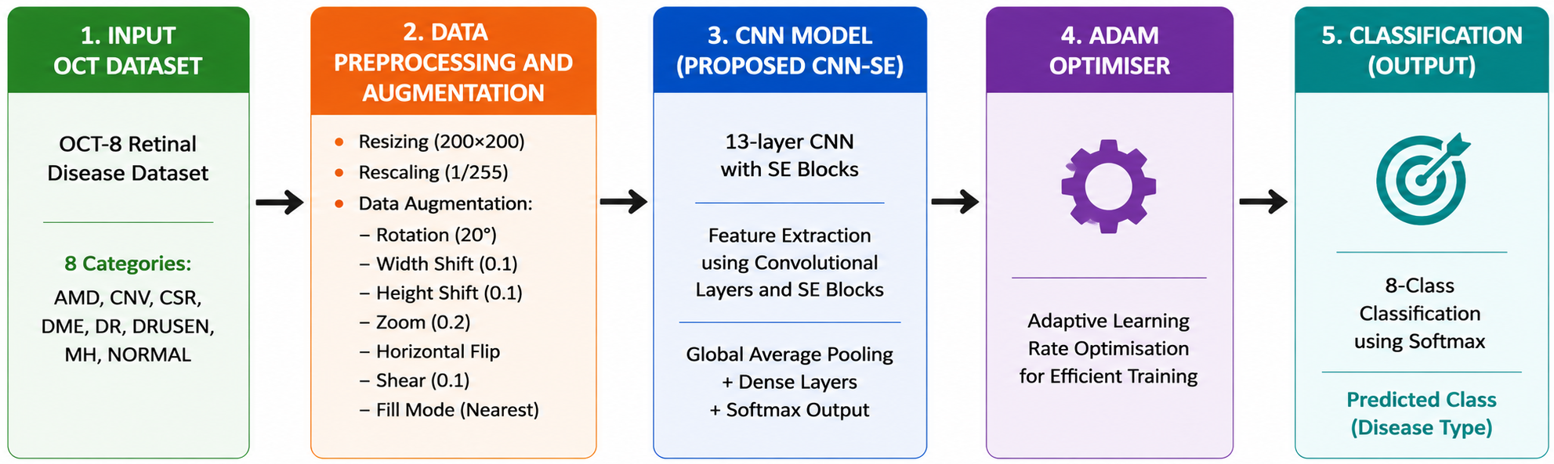
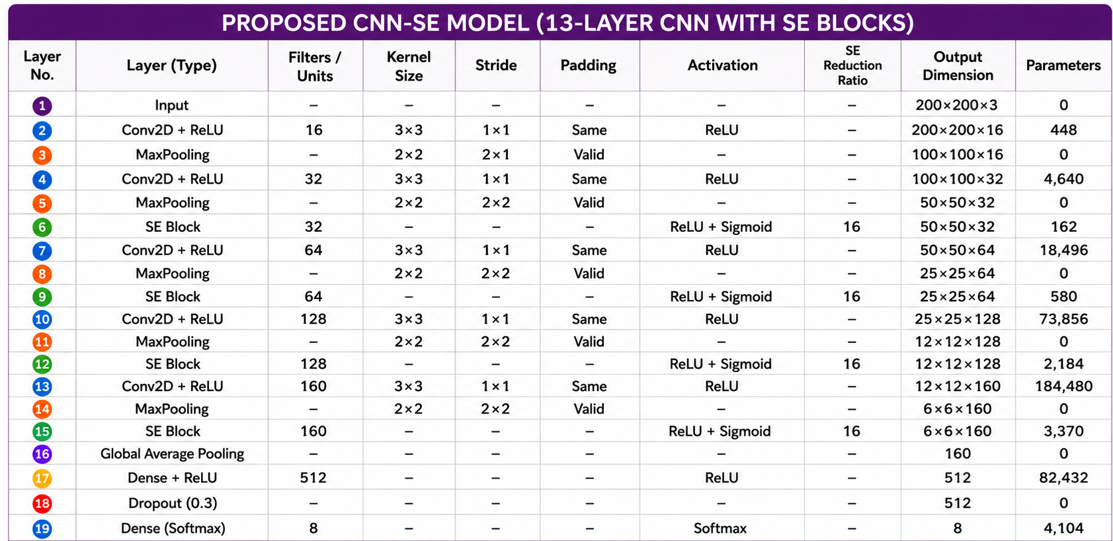
Fig. 1. Proposed CNN Model (OCT-C8: 8 Class, OCT 2017: 4 Class)

- Data Preparation
The OCT-C8 dataset [26] contains 8 classes: Drusen, MH, AMD, CNV, CSR, DME, DR, and Normal. There are 2,800 validation (350 per class), 2800 test images (350 per class) and 18,400 training images (2,300 per class). Feature extraction is more difficult because each image has a resolution of 96 dpi with a 24-bit depth and contains noise and different intensity patterns.
The OCT2017 dataset [17] comprises 83,484 training images, 968 test images (242 per class), and 32 validation images, divided into four classes: CNV, DME, Drusen, and Normal. While example samples, the training images vary in size and contain noise. The publicly available OCT dataset was used as provided by its original authors, with images collected from different patients. Before model training, the images were resized to 200 × 200 pixels using bilinear interpolation, converted to RGB format, and normalized to the range [0,1]. No additional quality screening or duplicate removal was performed, as the dataset was used in its original curated form.

- Data Augmentation
By transforming the source images, image augmentation creates a variety of training examples that aid CNN in learning minor differences across comparable classes [29]. This lessens overfitting, increases generalization, and improves feature representation. Table 2 lists the augmentation settings utilized in the suggested strategy, which creates augmented images during training without storing them permanently.
To improve the model’s ability to generalize while preserving the anatomical characteristics of retinal OCT images, augmentation was applied exclusively to the training set. The training images were subjected to controlled transformations, including horizontal flipping, small-angle rotation, limited horizontal and vertical translation, moderate zooming, and mild shearing, to introduce realistic variations in image appearance and spatial alignment. These transformations increase the diversity of the training distribution and encourage the network to learn stable, discriminative retinal features rather than relying on specific image orientations or local patterns. Vertical flipping and excessive geometric transformations were deliberately avoided because they may alter the natural arrangement of retinal layers and produce anatomically unrealistic pathological patterns. The augmented samples were generated online during training, so the original images were not permanently duplicated and no augmentation was applied to the validation or test sets. Representative transformed images were also visually inspected to verify that retinal-layer continuity, tissue boundaries, and disease-related morphological structures remained identifiable after augmentation.
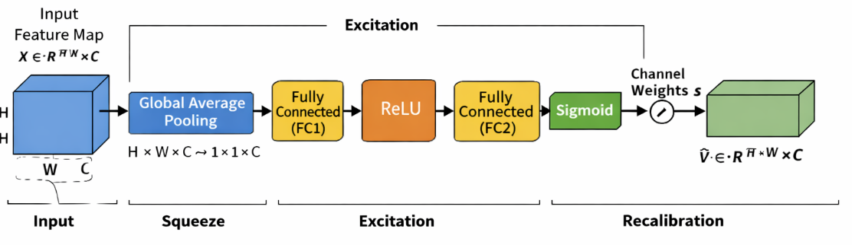
Fig. 2. Architecture of SE block

Table 2. Configuration Details of Image Transformation Techniques
Parameter Name | Parameter Value
Pixel value normalization | 1./255
Rotation angle | 20
Horizontal shift | 0.1
Height shift | 0.1
Zoom factor | 0.2
Horizontal flipping | True
Shear intensity | 0.1
Fill mode | Nearest

- Squeeze-and-Excitation Blocks
The Squeeze-and-Excitation (SE) block[26] by finding the most informative feature channels and simulating channel-wise dependencies, it enhances CNN feature learning. It produces more selective representations of features by enhancing significant traits while suppressing less important ones. The overall architecture for SE block is depicted in Fig. 2.
The operation of the SE block is divided into three key stages: squeeze, excitation, and recalibration. In the squeeze stage, global average pooling is applied to the input feature map $X ∈R^{H* W* C}$ to produce a channel-wise descriptor. In this stage, each channel's spatial dimensions H×W are reduced into one representative value, effectively capturing the global distribution of feature responses. Mathematically, the output of the squeeze operation for the Cth channel is computed as Eq. (1)[30] where Z_{c}​ represents the aggregated statistic of the Cth channel. This descriptor encodes the global contextual information and reflects the overall importance of each channel.

$$Z_{c}=\frac{1}{H*W}\sum_{i=1}^{H}{\sum_{j=1}^{W}{X_{c}\left(i,j\right)}}$$ | (1)

After the squeeze stage, the excitation module learns the importance of each channel using two dense layers with a bottleneck structure. ReLU [31] and sigmoid activations generate normalized channel-wise weights that emphasize informative features while reducing computational cost. This process can be expressed as Eq. (2)[30]

$$S= σ(W_{2}*δ\left(W_{1}*z\right))$$ | (2)

where “z” is the squeezed vector, W₁​ and W₂​ are the learnable parameters of the fully connected layers, δ denotes the ReLU [31] activation, and σ represents the sigmoid function.
In the final feature refinement step, the learned channel parameters are applied to the actual feature map. Each feature channel is scaled based on its assigned importance value, enabling the network to highlight the most meaningful features while minimizing the influence of less important ones. This is given by Eq. (3)[30].

$$\tilde{X}=s_{c}*X_{c}$$ | (3)
where S_{c}​ is the learned weight for the Cth channel. This feature refinement process improves the network's ability to learn meaningful channel-wise information by giving major emphasis to the most pertinent attributes while simultaneously diminishing the impact of less beneficial ones. As a result, the model achieves better classification performance with only a small increase in computational cost.
The global average pooling of SE block can be depicted by Eq. (4)[30]

$G_{c}= \frac{1}{H x W}\sum_{i=1}^{H}{\sum_{j=1}^{W}{X_{c}(i,j)}}$ (4)

- Adam Optimizer
The Adam optimizer is a widely used method for training deep learning models due to its ability to perform well in a variety of scenarios. It integrates the concepts of adaptive learning and momentum, allowing the model to adjust how much each parameter is updated during training. Instead of using the same learning rate for all parameters, Adam adapts it based on the behavior of the gradients, which helps the model learn more efficiently and with better stability. Eq. (5)[32] computes the first moment vector using the first hyperparameter (typically 0.9) to maintain an exponentially decaying average of past gradients that tracks directional momentum.
$m_{t}= β_{1}m_{t-1}+(1-β_{1})g_{t}$ (5)

Eq. (6)[32] calculates the uncentered second moment vector using the second hyperparameter (typically 0.999) to track gradient variance by maintaining an exponentially decaying average of squared gradients.
$v_{t}= β_{2}v_{t-1}+(1-β_{2})g_{t}^{2}$ (6)

Eq. (7)[32] yields the bias-corrected first moment estimate by dynamically adjusting the time step, which compensates for the moving average's initial bias toward zero.
${\hat{m}}_{t}= \frac{m_{t}}{1-β_{1}^{t}}$ (7)
Eq. (8) [32]derives the bias-corrected second moment estimate by adjusting for the time step, correcting the initial zero-bias in variance tracking during early iterations.
${\hat{v}}_{t}=\frac{v_{t}}{1-β_{2}^{t}}$ (8)
Eq. (9)[32] updates the model parameters by adjusting the learning rate with the ratio of these bias-corrected moments, providing adaptive step sizes stabilized by a small constant.

$θ= θ- α* \frac{m}{\left(\sqrt{v}\right)+\left(∈\right)}$ (9)
In above Eqs. (5) to (9), $m_{t}$ and $v_{t}$ denote the first- and second-moment estimates, $\hat{m_{t}}$ and $\hat{v_{t}}$ are their bias-corrected forms, $g_{t}$ represents the gradient at iteration t, $β_{1}$ and $β_{2}$ are the decay rates, α is the learning rate, and ɛ is a small constant for numerical stability. m captures the average of past gradients and v represents the average of their squared values.
These estimates are continuously updated during training, helping the optimizer adapt to the shape of the loss function. Because of this adaptive behaviour, Adam tends to converge faster and requires less manual tuning compared to traditional optimization methods. It performs particularly well in problems involving large datasets, high-dimensional pameters, or noisy gradients

- CNN Architecture
The proposed CNN processes 200×200×3 OCT images through successive convolution and max-pooling layers to learn hierarchical image features. SE blocks are incorporated after each stage to emphasize important feature channels while suppressing less relevant ones. The gradual increase in filters enables effective feature extraction, leading to improved retinal OCT image classification. The extracted feature maps are condensed using global average pooling and passed to a 512-neuron dense layer with 0.3 dropout to improve generalization. A softmax layer then produces the final class predictions for the OCT-C8 and OCT2017 datasets.
A 2x2 max-pooling procedure follows each convolutional layer to preserve the most informative features while reducing the size of the feature map by keeping just the strongest activations. As seen in Fig. 3 and Eq. (10)[33][34], this increases the computing efficiency and aids in the model’s learning of more robust features.
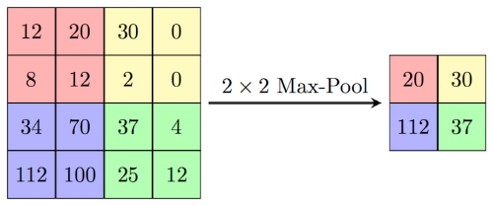
Fig. 3. Illustration of 2x2 max pooling

$$MaxPool(x)=max⁡(x_{ij}) _{1≤i≤k,1≤j≤k}$$ | (10)
The ReLU [31] activation function is used throughout the CNN to introduce non-linearity by retaining positive values and suppressing negative ones. Its computational efficiency and ability to mitigate the vanishing gradient problem enable faster and more stable network convergence. The mathematical equation is depicted by Eq. (11) [31]
F(x) = max(x, 0) | (11)
The 6×6×160 feature maps are compressed by global average pooling into a 1×1×160 feature vector following the final convolution and max-pooling stage, and then they are sent to a 512-neuron dense layer for discriminative feature learning. To lessen overfitting and enhance model generalisation, a dropout rate of 0.3 is used during training. Eight neurons are used in the last output layer for the OCT-C8 [23] dataset and four neurons for the OCT2017 [15] dataset, with each neuron representing a distinct class to generate the final classification results. The last layer uses the softmax activation function to calculate the likelihood of each output class. Using these probabilities, the framework assigns the input picture to the class with the greatest confidence score. The suggested model minimizes the discrepancy between the true and predicted class labels during training by using categorical cross-entropy loss for multi-class classification.
The equation, Eq. (12)[8][10] , represents a 2D convolutional layer where a filter matrix with a bias value slide across an input image to calculate a weighted sum at each overlapping region. This mathematical operation extracts localized spatial features from the input data to produce a specific coordinate pixel value within the output feature map, as detailed in Eq. (12)[8][10].

$Y\left(i,j\right)= \sum_{m=0}^{K-1}{\sum_{n=0}^{K-1}{X\left(i+m,j+n\right)*W\left(m,n\right)+b}}$ (12)

The spatial dimensions of the output feature map after convolution are calculated Eq. (13)[8], determines the final spatial output size of a feature map by adding twice the padding (P) to the input dimension (N) and subtracting the kernel size (K). This result is then divided by the stride rate (S), rounded down to the nearest integer using the floor function, and increased by one to account for the final filter placement, as outlined in Eq. (13)[8].

$O= \left\lfloor \frac{N-K+2P}{S}\right.\left.\frac{ }{ }\right\rfloor +1$ (13)
The mathematical formulation of the softmax function is presented in Eq. (14)[35]. The function transforms the output values of the network into normalized probability scores ranging from 0 to 1, with the total probability across all classes equal to one. In Eq. (14)[35], Z represents the input vector received by the output layer, and j refers to an individual output neuron, where j = 1, 2, ..., K.
$${σ(z)}_{j}= \frac{e^{{(z)}_{j}}}{\sum_{k=1}^{K}{e^{{(z)}_{k}}}}$$ | (14)
The dense layer transforms the extracted features into a higher-level representation as shown in Eq. (15)[9] , where (W) denotes the weight matrix, (x) represents the input feature vector, (b) is the bias, and (f(.)) denotes the ReLU activation function.This transformation enables the network to learn complex feature representations for accurate classification
$h=f\left(Wx+b\right)$ (15)
As discussed, earlier dropout cand be denoted by Eq. (16)[36] which reduces the overfitting to make a model generalized one.
$h_{drop}=r ⨀ h$ , $r ∼Bernoulli(p)$ (16)

Results
The proposed CNN–SE model was implemented in Python 3.12.13 using TensorFlow 2.21.0, Keras, scikit-learn, and Matplotlib on an AMD Ryzen 7 5700G (3.80 GHz) CPU with 16 GB RAM. The model used 200 × 200 × 3 input images, a batch size of 32, Adam optimization with a learning rate of 0.001, categorical cross-entropy loss, an SE reduction ratio of 16, and a dropout rate of 0.30. Training was performed for a maximum of 100 epochs with early stopping (patience = 20), retaining the best-performing weights; convergence occurred at epoch 31 for OCT2017 [17] and epoch 63 for OCT-C8 [26]. The same hyperparameter configuration was applied to both datasets without test-set-specific tuning. OCT-C8 [26] contained 18,400 training and 2,800 validation/testing images, whereas OCT2017 [17] contained 83,484 training, 32 validation, and 968 testing images. The lightweight CNN–SE model required approximately 13 h/109 ms for training/testing on OCT2017 and 6 h/144 ms on OCT-C8. Performance was comprehensively evaluated using confusion matrices, ROC curves, training–validation curves, and class-wise evaluation metrics.

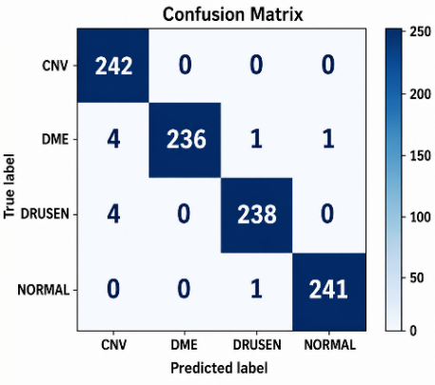 | 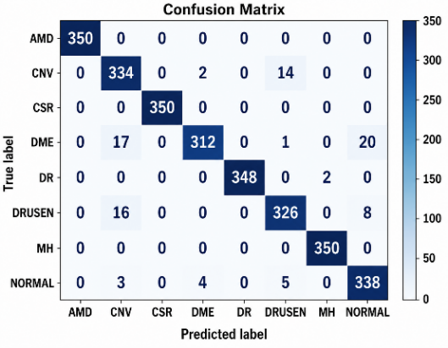
Fig. 4. Confusion matrix for OCT2017(left) and OCT-C8(right) test datasets

confusion matrices, ROC curves, training–validation curves, and class-wise evaluation metrics.
The confusion matrices for the OCT2017 and OCT-C8 test datasets are presented in Fig. 4. Most predictions are concentrated along the diagonal, indicating effective discrimination across the evaluated retinal categories, although a small number of errors were observed, particularly for DME and Drusen in OCT2017.
The training and validation loss curves for the OCT2017 and OCT-C8 datasets are shown in Fig. 5(a) and Fig. 5(b). Smooth decreases in both curves with a small training–validation gap indicate stable convergence without substantial overfitting. Owing to its larger training set, fewer classes, and lower inter-class complexity, OCT2017 converges faster than OCT-C8. The corresponding training and validation accuracy curves are presented in Fig. 6(a) and Fig. 6(b), showing a consistent increase with closely aligned curves, which indicates stable learning and good generalization. Although OCT-C8 converges more slowly because of its higher class complexity and inter-class similarity, the model maintains strong classification performance on both datasets.
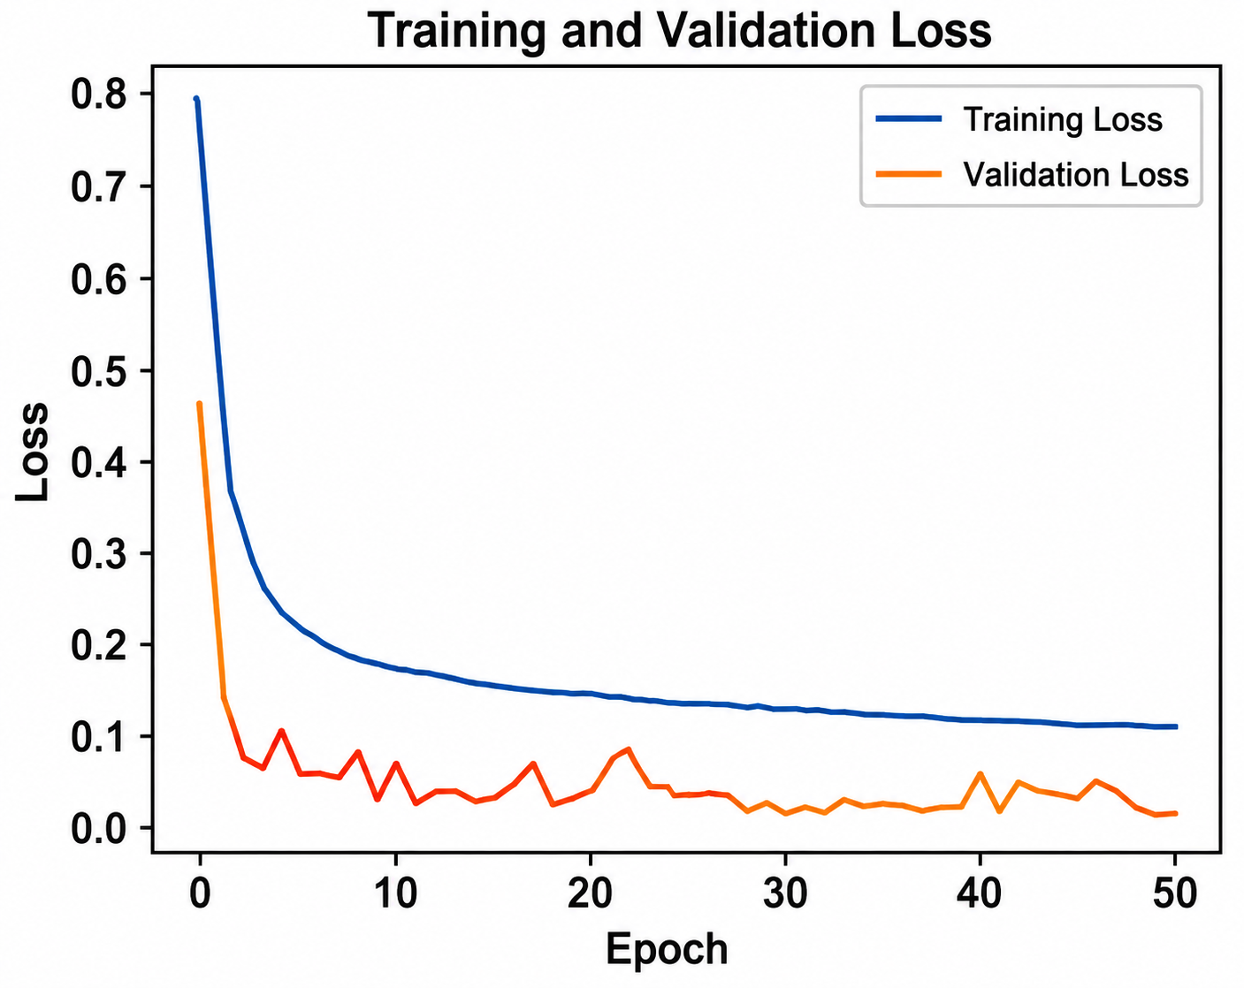
(a)
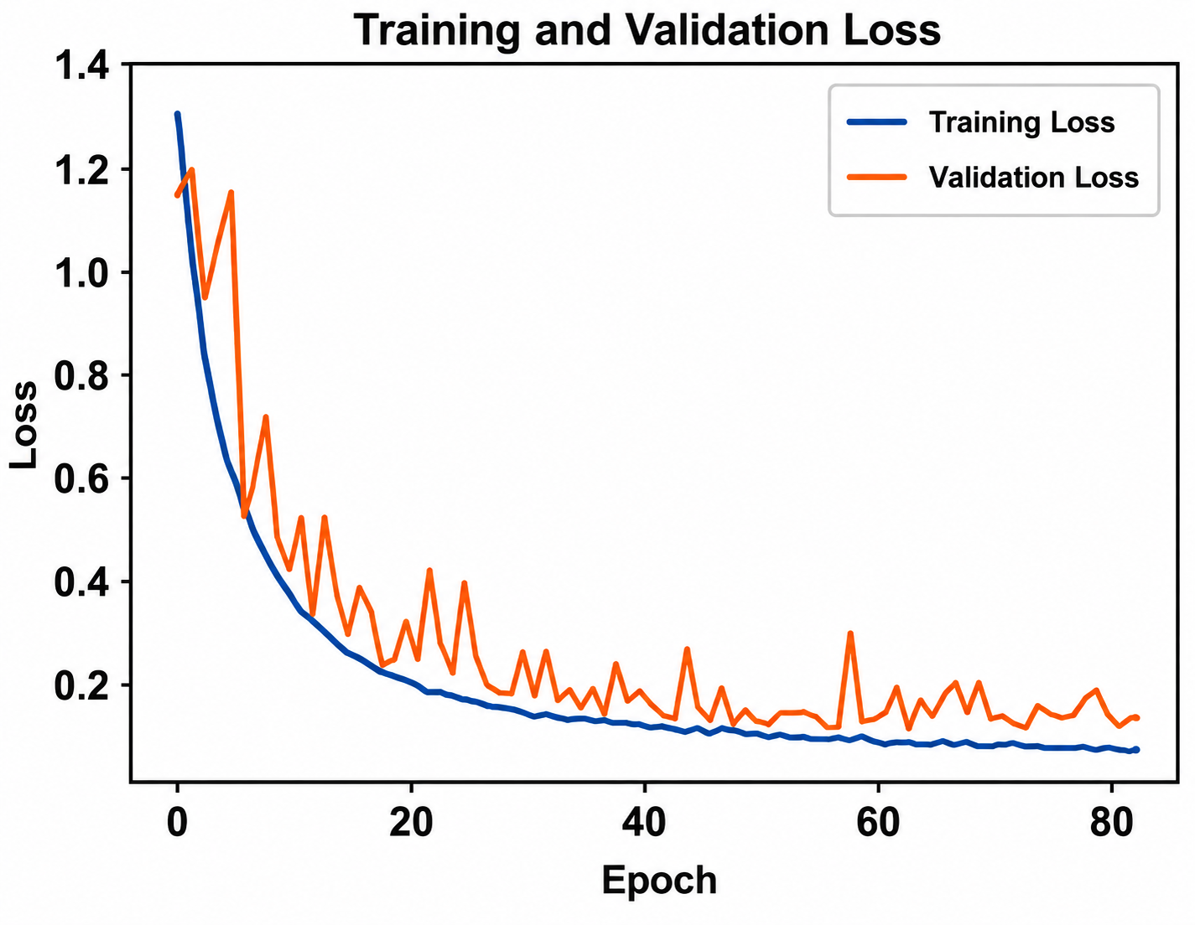
(b)
Fig. 5 (a) Training and validation loss for OCT2017 dataset (b) Training and validation loss for OCT-C8 dataset
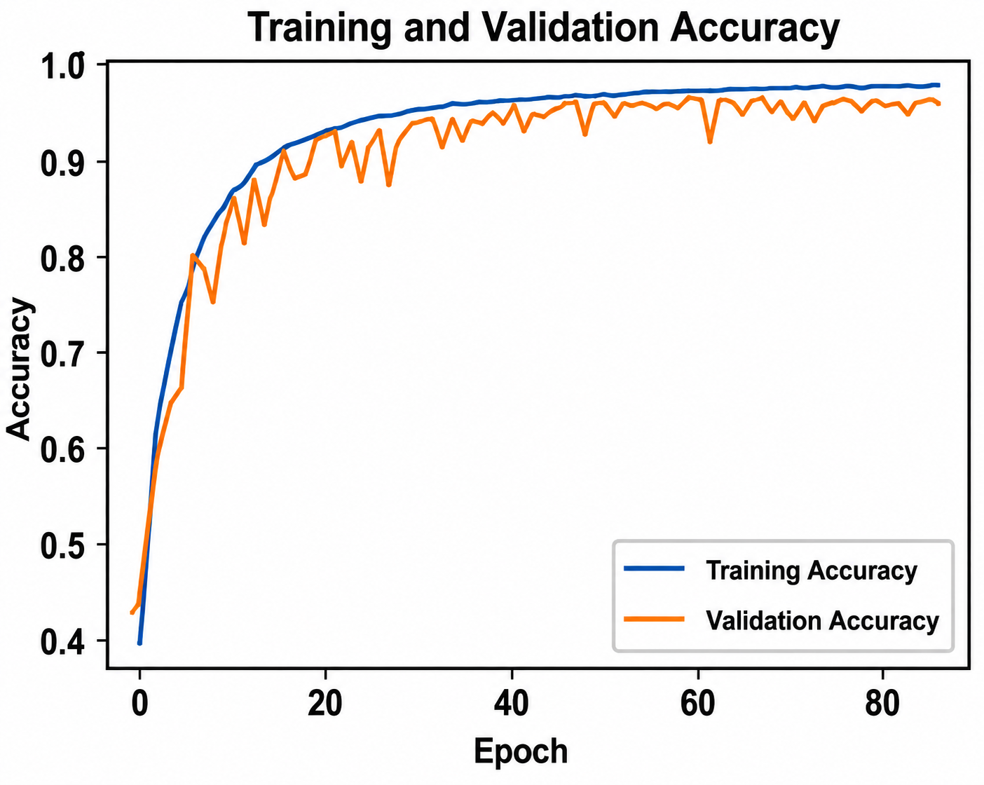
(b)
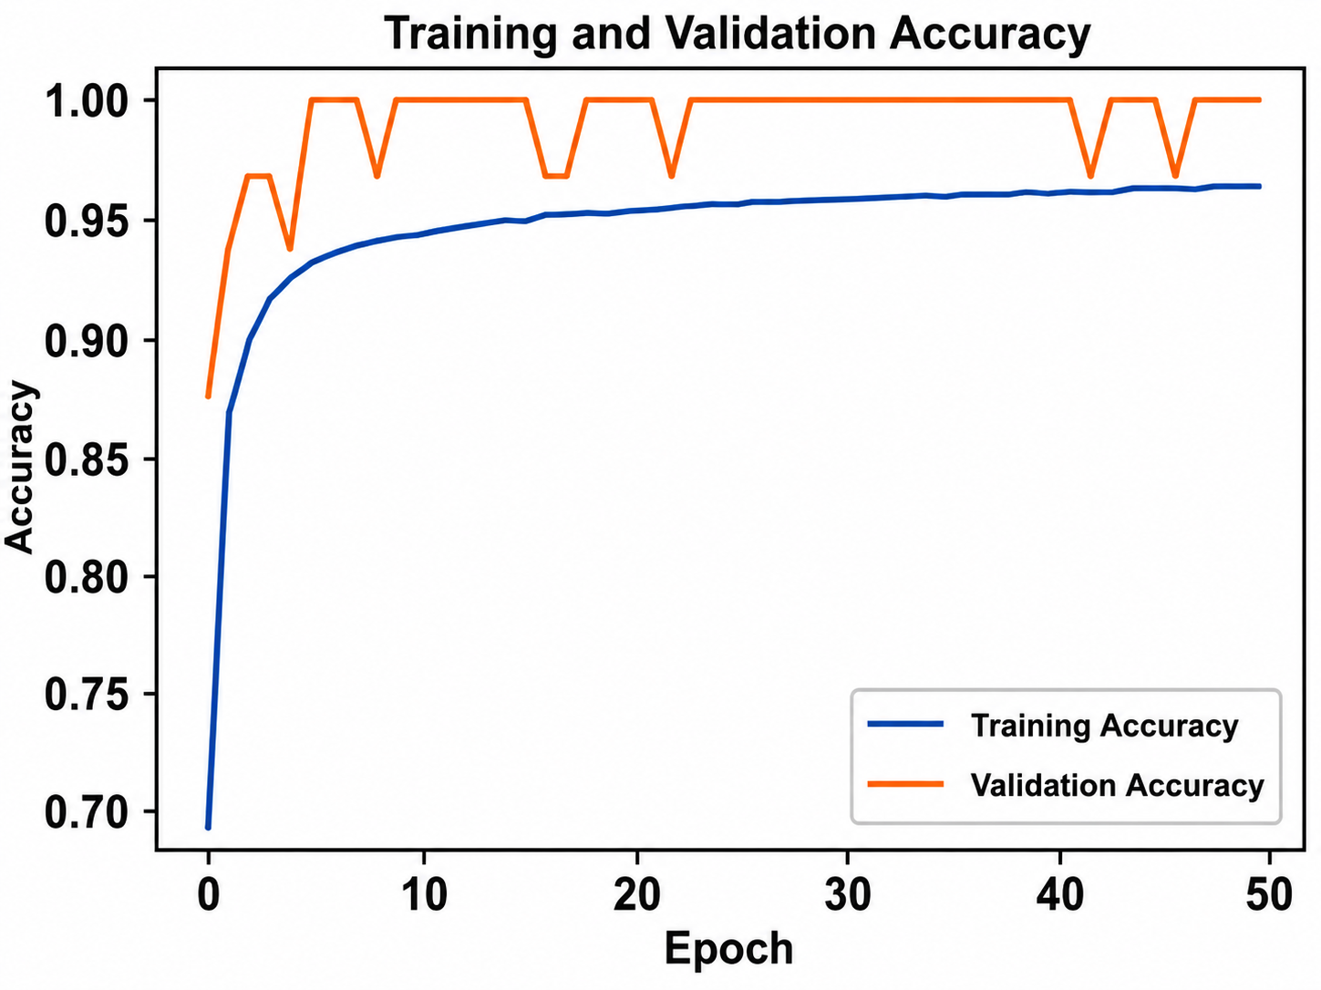
(a)
Fig. 6 (a). Training and validation accuracy for OCT2017 dataset (b). Training and validation accuracy for OCT-C8 dataset

Table 3 summarizes the class-wise performance of the proposed CNN-SE model. The model achieved 99% accuracy on OCT2017 and 97% on OCT-C8, with macro- and weighted-average precision, recall, and F1-scores of 0.99 and 0.97, respectively. Strong class-wise performance was observed across the evaluated retinal categories, despite the greater class diversity and morphological similarity in OCT-C8 The model was evaluated using Eqs. (17), (18), (19) and (20)[37][38]
$Accuracy= \frac{TP+TN}{TP+TN+FP+FN}$ (17)
$Precision= \frac{TP}{TP+FP}$ (18)
$Recall= \frac{TP}{TP+FN}$ (19)
$F1-Score=2* \frac{Precision*Recall}{Precision+Recall}$ (20)

Table 3 Class-wise Classification Results of CNN-SE Model for OCT2017 and OCT-C8 datasets
 | OCT 2017 |  |  |  | OCT-C8
 | Precision | Recall | F1-score | Support | Precision | Recall | F1-score | Support
Class
AMD | Class Not Available |  |  |  | 1.00 | 1.00 | 1.00 | 350
CNV | 0.97 | 1.00 | 0.98 | 242 | 0.90 | 0.95 | 0.93 | 350
CSR | Class Not Available |  |  |  | 1.00 | 1.00 | 1.00 | 350
DME | 1.00 | 0.98 | 0.99 | 242 | 0.98 | 0.89 | 0.93 | 350
DR | Class Not Available |  |  |  | 1.00 | 0.99 | 1.00 | 350
Drusen | 0.99 | 0.98 | 0.99 | 242 | 0.94 | 0.93 | 0.94 | 350
MH | Class Not Available |  |  |  | 0.99 | 1.00 | 1.00 | 350
Normal | 1.00 | 1.00 | 1.00 | 242 | 0.92 | 0.97 | 0.94 | 350
Accuracy |  |  | 0.99 | 968 |  |  | 0.97 | 2800
Macro Avg | 0.99 | 0.99 | 0.99 | 968 | 0.97 | 0.97 | 0.97 | 2800
Weighted Avg | 0.99 | 0.99 | 0.99 | 968 | 0.97 | 0.97 | 0.97 | 2800

- Cross-Dataset Validation
To further examine domain robustness, the CNN-SE model was trained exclusively on OCT-C8 and evaluated directly on the OCT2017 dataset without retraining or fine-tuning, using the four shared diagnostic classes, namely CNV, DME, Drusen, and Normal. Across five repeated experiments with random seeds 11, 22, 33, 44, and 55, The cross-dataset evaluation, summarized in Table 4, achieved 98.74 ± 0.11% accuracy, with weighted precision, recall, and F1-score of 98.75 ± 0.12%, 98.74 ± 0.11%, and 98.74 ± 0.11%, respectively. The macro-ROC-AUC was 0.9995 ± 0.0002, with a compatible prediction rate of 100.00 ± 0.00% across the five repeated experiments as shown in Table 4.
- Computational Efficiency and Inference Performance
Table 5 compares the computational characteristics of the proposed SE-CNN with MobileNetV2, EfficientNetB0, and NASNetMobile. The proposed model contains 0.3748 M trainable parameters, requires 0.3670 G FLOPs and 183.52 M MACs, and occupies 1.54 MB. It achieves an average latency of 9.40 ms/image and a throughput of 106.40 images/s. Table 6 summarizes the within- and cross-dataset performance of the proposed CNN-SE model. On OCT-C8, the model achieved 97.00% accuracy with a macro-AUROC of 0.9985. For cross-dataset evaluation, it achieved 98.74 ± 0.11% accuracy, 0.9995 ± 0.0002 macro-AUROC, 0.9832 ± 0.0015 MCC, and 0.9832 ± 0.0015 Cohen’s k

Table 4. Cross-Dataset Testing Performance of the Proposed CNN-SE Model Across Five Random Seeds
Metric | Mean | SD | Mean ± SD
Accuracy | 0.987397 | 0.001132 | 98.74 ± 0.11%
Weighted Precision | 0.987460 | 0.001153 | 98.75 ± 0.12%
Weighted Recall | 0.987397 | 0.001132 | 98.74 ± 0.11%
Weighted F1-score | 0.987397 | 0.001141 | 98.74 ± 0.11%
Macro F1-score | 0.987397 | 0.001141 | 98.74 ± 0.11%
Macro ROC-AUC | 0.999545 | 0.000236 | 0.9995 ± 0.0002
Compatible Prediction Rate | 1.000000 | 0.000000 | 100.00 ± 0.00%

Table 5 Computational Efficiency Comparison of CNN Models
Model | Parameters (Millions) | FLOPs (G) | MACs (M) | Model Size (MB) | Peak Memory (MB) | Latency (ms/image) | Throughput (images/s)
Proposed SE-CNN | 0.3748 | 0.3670 | 183.52 | 1.54 | 0.00 | 9.40 | 106.40
MobileNetV2 | 2.2682 | 0.5342 | 267.09 | 9.21 | 0.0039 | 42.13 | 23.74
EfficientNetB0 | 4.0598 | 0.7083 | 354.16 | 16.29 | 0.0312 | 62.01 | 16.13
NASNetMobile | 4.2782 | 0.9983 | 499.15 | 18.95 | 0.0703 | 82.93 | 12.06

Table 6 Within-Dataset and Cross-Dataset Validation Results
Train Dataset → Test Dataset | Test Set (#) | Accuracy (%) | Macro-AUROC | MCC | Cohen’s κ
OCT-C8 → OCT-C8 | 2,800 | 97 | 0.9985 | 0.9626 | 0.9624
OCT-C8 → OCT2017 | 968 | 98.74 ± 0.11 | 0.9995 ± 0.0002 | 0.9832 ± 0.0015 | 0.9832 ± 0.0015

- Ablation Study
The ablation study evaluated the individual contributions of SE blocks, data augmentation, and optimizer selection using the OCT2017 and OCT-C8 datasets. The model configurations, including the baseline without SE blocks, are illustrated in Fig. 1. As shown in Table 7, Model E, combining SE blocks, data augmentation, and Adam optimization, achieved the highest accuracy of 99.0% on OCT2017 and 97.0% on OCT-C8. Table 8 shows that data augmentation improved accuracy by 1.60 and 1.80 percentage points, SE blocks by 1.70 and 2.07 percentage points, and replacing SGD with Adam by 3.70 and 2.90 percentage points on OCT2017 and OCT-C8, respectively. Among the evaluated components, the optimizer changes from SGD to Adam produced the largest improvement. Alternative SE reduction ratios, pooling strategies, and dropout rates were not evaluated.
- Explainable AI
Grad-CAM analysis was performed across the eight OCT-C8 classes, as illustrated in Fig. 7. The activation maps highlighted localized retinal regions contributing to the model predictions, with prominent responses observed around abnormal retinal structures in AMD, CNV, CSR, DME, DR, Drusen, and MH. For Normal samples, activations were generally more localized within the retinal layers. The visualizations also include representative misclassified samples, highlighting regions associated with the corresponding incorrect predictions and challenging class boundaries.

Discussions
The results demonstrate that the proposed CNN-SE architecture achieves a favorable balance between classification performance and computational efficiency. The strong diagonal patterns in Fig. 4 indicate effective class discrimination, while the remaining errors were mainly associated with CNV, DME, Drusen, and Normal in OCT-C8, where overlapping retinal characteristics can make class boundaries less distinct. The training and validation curves in Figs. 5 and 6 show stable convergence with no substantial evidence of overfitting.
The cross-dataset findings in Tables 4 and 6 indicate that the learned representations remain effective on an independent dataset without retraining or fine-tuning, supporting the generalization capability of the proposed model. The ablation results in Tables 7 and 8 further shows that SE blocks, data augmentation, and optimizer selection contribute to overall performance, with Adam producing the largest observed improvement.
As shown in Table 5, the model maintains a compact computational profile while providing efficient inference, indicating that SE-based feature recalibration can be incorporated without substantially compromising computational efficiency. The Grad-CAM visualizations in Fig. 7 highlight retinal regions associated with model predictions and provide qualitative insight into challenging cases. Overall, the findings suggest that CNN-SE offers a practical combination of classification performance, generalization, computational efficiency, and interpretability, although further validation on diverse clinical datasets is required

Table 7 Ablation study of different model implementations
Model | SE Blocks | Data Augmentation | Optimizer | Accuracy (OCT2017) | Accuracy (OCT-C8)
Model A | No | No | Adam | 96.2% | 92.8%
Model B | No | Yes | Adam | 97.8% | 94.6%
Model C | Yes | No | Adam | 97.9% | 94.87%
Model D | Yes | Yes | SGD | 95.3% | 94.1%
Model E (Proposed Model) | Yes | Yes | Adam | 99.0% | 97.0%

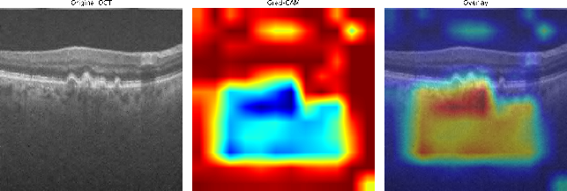  AMD | 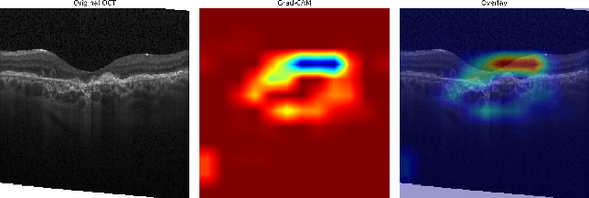  CNV
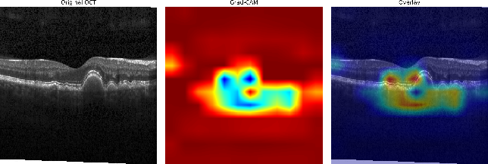  DRUSEN | 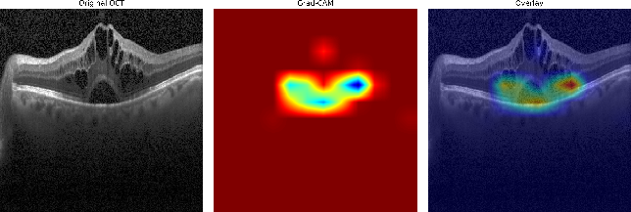  DME
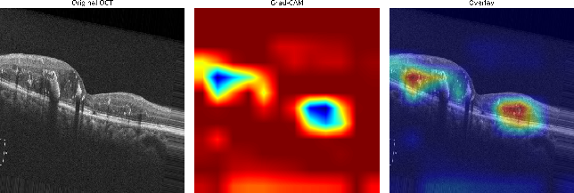  DR | 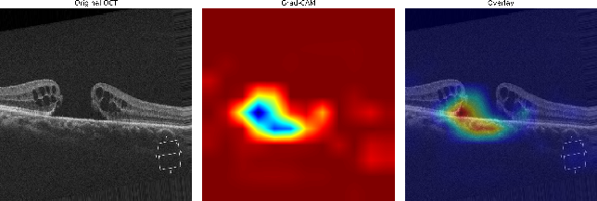  MH
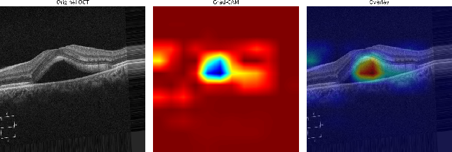  CSR | 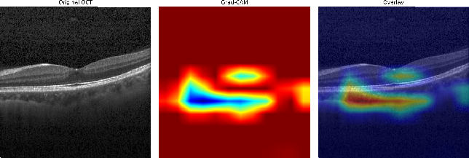  Normal
Fig. 7. Grad-CAM visualizations of representative OCT-C8 dataset

Table 9 shows that the proposed CNN-SE model achieves competitive classification performance with a substantially smaller parameter count than most of the compared approaches. Reported accuracies on OCT2017 range from 87.20% to 98.70% among the listed methods, whereas the proposed model achieves 99.00%. The approximate parameter counts also vary considerably, from 0.95 M for Saraiva et al. [40] to 452.1 M for the larger Kim et al. [18] variant, while Huang et al. [16], Hassan et al. [20], Michael Opoku et al. [41], Stanojević et al. [24], and Yang et al. [23] use approximately 24.88 M, 25.64 M, 8.2 M, 6.6 M, and 21.4 M parameters, respectively. In comparison, the proposed CNN-SE contains approximately 0.375 M trainable parameters while achieving 99.00% accuracy on OCT2017 and 97.00% on the eight-class OCT-C8 dataset. The proposed evaluation also extends beyond within-dataset accuracy through direct OCT-C8-to-OCT2017 testing without retraining or fine-tuning, achieving 98.74 ± 0.11% accuracy across five random seeds. Together, these results indicate that the proposed architecture provides a favorable balance between predictive performance, model compactness, and cross-dataset generalization.
The Grad-CAM analysis also provides an additional layer of transparency by showing image regions associated with model predictions. Nevertheless, high performance on curated public datasets does not by itself establish clinical reliability. Variations in patient populations, imaging devices, acquisition conditions, and disease presentation should be considered in future evaluations. Broader multi-center and prospective studies would therefore be valuable for determining the robustness and practical applicability of the proposed CNN-SE framework.
.
Table 8 Component wise ablation study analysis (pp = percentage point)
Comparison | Component isolated | OCT2017 Accuracy Change | OCT-C8 Accuracy Change
Model A → Model B | Data augmentation | +1.60 pp | +1.80 pp
Model A → Model C | SE blocks | +1.70 pp | +2.07 pp
Model D → Model E | Optimizer (SGD → Adam) | +3.70 pp | +2.90 pp
Model C → Model E | Data augmentation | +1.10 pp | +2.13 pp

Table 9. Comparison with existing approaches
Publication Year | References | Approach | Acc (OCT2017 Dataset) | Acc (OCT-C8 Dataset)
2019 | L.Huang et al. [16] | Layer-guided convolutional neural network | 88.4
2020 | Le et al.[39] | Transfer learning | 87.20
2020 | Saraiva et al. [40] | Deep CNN architecture | 93.3
2021 | J Kim et al. [18] | Two binary CNN variants (Model 1 / Model 2 with high computational complexity) | 98.1/98.7
2023 | Hassan E et al [20] | Enhanced Optical Coherence Tomography (EOCT)-based framework | 97.47
2023 | Diao et al. [19] | CNN-based classification framework | 96.93
2023 | Michael Opoku et al. [41] | Capsule network integrated with contrast-limited adaptive histogram equalization | 97.7
2024 | Stanojevi´c, M et al. [24] | Deep convolutional neural network model | 95.55
2024 | Yang J et al. [23] | CNN, EfficientNet-V2, and ResNet-based ensemble architecture | 97.89
2025 | Dave and Domadiya et al. [28] | CNN with data augmentation, exponential learning rate decay, and hybrid max–average pooling | 98.75
2026 | Proposed Model | CNN enhanced with SE blocks, Adam optimization, and global average pooling | 99.00 | 97.00

Conclusion and Future Work
This study presented a lightweight CNN-SE framework for retinal OCT image classification by integrating SE blocks, data augmentation, and the Adam optimizer. The proposed model achieved 99.00% and 97.00% accuracy on the OCT2017 and OCT-C8 datasets, respectively, while maintaining a compact computational profile. The five-seed cross-dataset evaluation further achieved 98.74 ± 0.11% accuracy and 0.9995 ± 0.0002 macro-ROC-AUC when the model trained on OCT-C8 was evaluated directly on OCT2017, providing evidence of robustness across the two dataset distributions. Grad-CAM analysis also provided visual insight into the image regions contributing to the model predictions.
Despite these encouraging findings, several limitations should be considered. The study relies on publicly available curated datasets, and no external hospital-based prospective validation was performed. Differences in OCT scanners, acquisition protocols, patient populations, and clinical settings may therefore affect model performance under real-world conditions. In addition, patient-level prospective testing was not available in the present study. Future work will focus on evaluating the proposed model using multi-center, hospital-based OCT datasets with diverse acquisition conditions, patient-level evaluation, and prospective clinical validation to establish its robustness and clinical applicability.
Acknowledgment
NA
Funding
NA

Data Availability
No datasets were generated during the current study. The datasets used in the research are publicly available and we have cited it properly in the paper [17] and [26].
Author Contribution
Parth R. Dave:- Conceptualization, methodology, data curation, model implementation, formal analysis, manuscript drafting, review and editing, and project coordination.
Nikunj H. Domadiya:- Conceptualization, methodology, supervision, performance evaluation, formal and statistical analysis, visualization, manuscript drafting, review and editing.
Jaiwal Patel:- Mathematical foundation, abstract analysis, manuscript editing and drafting, project execution, and ablation study
Declarations
The authors declare no conflict of interest.

Consent for Publication Participants.
Consent for publication was given by all participants

Competing Interests
The authors declare no competing interests.
References

[1] T. Ojala, M. Pietikainen, and T. Maenpaa, “Multiresolution gray-scale and rotation invariant texture classification with local binary patterns,” IEEE Trans. Pattern Anal. Mach. Intell., vol. 24, no. 7, pp. 971–987, Jul. 2002, doi: 10.1109/TPAMI.2002.1017623.
[2] N. Dalal and B. Triggs, “Histograms of Oriented Gradients for Human Detection,” in 2005 IEEE Computer Society Conference on Computer Vision and Pattern Recognition (CVPR’05), IEEE, pp. 886–893. doi: 10.1109/CVPR.2005.177.
[3] R. M. Haralick, K. Shanmugam, and I. Dinstein, “Textural Features for Image Classification,” IEEE Trans. Syst. Man Cybern., vol. SMC-3, no. 6, pp. 610–621, Nov. 1973, doi: 10.1109/TSMC.1973.4309314.
[4] G. Li, G. Wang, Q. Wang, F. Fei, S. Lü, and D. Guo, “ANN: a heuristic search algorithm based on artificial neural networks,” in Proceedings of the 1st International Conference on Intelligent Information Processing, in ICIIP ’16. New York, NY, USA: Association for Computing Machinery, 2016. doi: 10.1145/3028842.3028893.
[5] M. A. Hearst, S. T. Dumais, E. Osuna, J. Platt, and B. Scholkopf, “Support vector machines,” IEEE Intelligent Systems and their Applications, vol. 13, no. 4, pp. 18–28, Jul. 1998, doi: 10.1109/5254.708428.
[6] R. Chauhan, K. K. Ghanshala, and R. C. Joshi, “Convolutional Neural Network (CNN) for Image Detection and Recognition,” in 2018 First International Conference on Secure Cyber Computing and Communication (ICSCCC), 2018, pp. 278–282. doi: 10.1109/ICSCCC.2018.8703316.
[7] B. Zoph, V. Vasudevan, J. Shlens, and Q. V. Le, “Learning Transferable Architectures for Scalable Image Recognition,” in 2018 IEEE/CVF Conference on Computer Vision and Pattern Recognition, IEEE, Jun. 2018, pp. 8697–8710. doi: 10.1109/CVPR.2018.00907.
[8] A. Krizhevsky, I. Sutskever, and G. E. Hinton, “ImageNet classification with deep convolutional neural networks,” Commun. ACM, vol. 60, no. 6, pp. 84–90, May 2017, doi: 10.1145/3065386.
[9] K. Simonyan and A. Zisserman, “Very Deep Convolutional Networks for Large-Scale Image Recognition,” Apr. 2015.
[10] K. He, X. Zhang, S. Ren, and J. Sun, “Deep Residual Learning for Image Recognition,” in 2016 IEEE Conference on Computer Vision and Pattern Recognition (CVPR), IEEE, Jun. 2016, pp. 770–778. doi: 10.1109/CVPR.2016.90.
[11] C. Szegedy et al., “Going deeper with convolutions,” in 2015 IEEE Conference on Computer Vision and Pattern Recognition (CVPR), IEEE, Jun. 2015, pp. 1–9. doi: 10.1109/CVPR.2015.7298594.
[12] P. P. Srinivasan et al., “Fully automated detection of diabetic macular edema and dry age-related macular degeneration from optical coherence tomography images,” Biomed. Opt. Express, vol. 5, no. 10, p. 3568, Oct. 2014, doi: 10.1364/BOE.5.003568.
[13] Y.-Y. Liu et al., “Computerized Macular Pathology Diagnosis in Spectral Domain Optical Coherence Tomography Scans Based on Multiscale Texture and Shape Features,” Investigative Opthalmology & Visual Science, vol. 52, no. 11, p. 8316, Oct. 2011, doi: 10.1167/iovs.10-7012.
[14] A. Maćkiewicz and W. Ratajczak, “Principal components analysis (PCA),” Comput. Geosci., vol. 19, no. 3, pp. 303–342, 1993, doi: https://doi.org/10.1016/0098-3004(93)90090-R.
[15] K. Alsaih et al., “Classification of SD-OCT volumes with multi pyramids, LBP and HOG descriptors: Application to DME detections,” in 2016 38th Annual International Conference of the IEEE Engineering in Medicine and Biology Society (EMBC), IEEE, Aug. 2016, pp. 1344–1347. doi: 10.1109/EMBC.2016.7590956.
[16] L. Huang, X. He, L. Fang, H. Rabbani, and X. Chen, “Automatic Classification of Retinal Optical Coherence Tomography Images With Layer Guided Convolutional Neural Network,” IEEE Signal Process. Lett., vol. 26, no. 7, pp. 1026–1030, Jul. 2019, doi: 10.1109/LSP.2019.2917779.
[17] D. S. Kermany et al., “Identifying Medical Diagnoses and Treatable Diseases by Image-Based Deep Learning,” Cell, vol. 172, no. 5, pp. 1122-1131.e9, Feb. 2018, doi: 10.1016/j.cell.2018.02.010.
[18] J. Kim and L. Tran, “Retinal Disease Classification from OCT Images Using Deep Learning Algorithms,” in 2021 IEEE Conference on Computational Intelligence in Bioinformatics and Computational Biology (CIBCB), IEEE, Oct. 2021, pp. 1–6. doi: 10.1109/CIBCB49929.2021.9562919.
[19] S. Diao et al., “Classification and segmentation of OCT images for age-related macular degeneration based on dual guidance networks,” Biomed. Signal Process. Control, vol. 84, p. 104810, Jul. 2023, doi: 10.1016/j.bspc.2023.104810.
[20] E. Hassan et al., “Enhanced Deep Learning Model for Classification of Retinal Optical Coherence Tomography Images,” Sensors, vol. 23, no. 12, p. 5393, Jun. 2023, doi: 10.3390/s23125393.
[21] C. S. Lee, D. M. Baughman, and A. Y. Lee, “Deep Learning Is Effective for Classifying Normal versus Age-Related Macular Degeneration OCT Images,” Ophthalmol. Retina, vol. 1, no. 4, pp. 322–327, 2017, doi: https://doi.org/10.1016/j.oret.2016.12.009.
[22] D. Paul, A. Tewari, S. Ghosh, and K. C. Santosh, “OCTx: Ensembled Deep Learning Model to Detect Retinal Disorders,” in 2020 IEEE 33rd International Symposium on Computer-Based Medical Systems (CBMS), IEEE, Jul. 2020, pp. 526–531. doi: 10.1109/CBMS49503.2020.00105.
[23] J. Yang, G. Wang, X. Xiao, M. Bao, and G. Tian, “Explainable ensemble learning method for OCT detection with transfer learning,” PLoS One, vol. 19, no. 3, p. e0296175, Mar. 2024, doi: 10.1371/journal.pone.0296175.
[24] M. Stanojević, D. Drašković, and B. Nikolić, “Retinal disease classification based on optical coherence tomography images using convolutional neural networks,” J. Electron. Imaging, vol. 32, no. 03, Nov. 2022, doi: 10.1117/1.JEI.32.3.032004.
[25] M. Selvarajan and M. B. N. M, “Impact of Optimizer Algorithm on NasNetMobile Model for Eight-class Retinal Disease Classification from OCT Images,” Journal of Electronics, Electromedical Engineering, and Medical Informatics, vol. 8, no. 2, pp. 490–503, Mar. 2026, doi: 10.35882/jeeemi.v8i2.1464.
[26] Obuli Sai Naren, “Retinal OCT Image Classification - C8 [Data set],” https://www.kaggle.com/datasets/obulisainaren/retinal-oct-c8/versions/2. Accessed: Jul. 20, 2026. [Online]. Available: https://doi.org/10.34740/KAGGLE/DSV/2736749
[27] F. E. Jannat, S. Gholami, M. N. Alam, and H. Tabkhi, “OCT-SelfNet: a self-supervised framework with multi-source datasets for generalized retinal disease detection,” Front. Big Data, vol. 8, 2025, doi: 10.3389/fdata.2025.1609124.
[28] P. R. Dave and N. H. Domadiya, “Lightweight deep learning approach for retinal OCT image classification: A CNN with hybrid pooling and optimized learning,” International Journal of Informatics and Communication Technology (IJ-ICT), vol. 15, no. 1, p. 414, Mar. 2026, doi: 10.11591/ijict.v15i1.pp414-427.
[29] Z. Yang, R. O. Sinnott, J. Bailey, and Q. Ke, “A survey of automated data augmentation algorithms for deep learning-based image classification tasks,” Knowl. Inf. Syst., vol. 65, no. 7, pp. 2805–2861, 2023, doi: 10.1007/s10115-023-01853-2.
[30] J. Hu, L. Shen, and G. Sun, “Squeeze-and-Excitation Networks,” in 2018 IEEE/CVF Conference on Computer Vision and Pattern Recognition, IEEE, Jun. 2018, pp. 7132–7141. doi: 10.1109/CVPR.2018.00745.
[31] V. Nair and G. E. Hinton, “Rectified Linear Units Improve Restricted Boltzmann Machines.”
[32] D. P. Kingma and J. Ba, “Adam: A Method for Stochastic Optimization,” CoRR, vol. abs/1412.6980, 2014, [Online]. Available: https://api.semanticscholar.org/CorpusID:6628106
[33] C. Szegedy et al., “Going deeper with convolutions,” in 2015 IEEE Conference on Computer Vision and Pattern Recognition (CVPR), 2015, pp. 1–9. doi: 10.1109/CVPR.2015.7298594.
[34] H. Wu and X. Gu, “Max-Pooling Dropout for Regularization of Convolutional Neural Networks,” vol. 9489, 2015, pp. 46–54. doi: 10.1007/978-3-319-26532-2_6.
[35] N. Srivastava, G. Hinton, A. Krizhevsky, I. Sutskever, and R. Salakhutdinov, “Dropout: a simple way to prevent neural networks from overfitting,” J. Mach. Learn. Res., vol. 15, no. 1, pp. 1929–1958, Jan. 2014.
[36] M. Sokolova and G. Lapalme, “A systematic analysis of performance measures for classification tasks,” Inf. Process. Manag., vol. 45, no. 4, pp. 427–437, 2009, doi: https://doi.org/10.1016/j.ipm.2009.03.002.
[37] T. Fawcett, “An introduction to ROC analysis,” Pattern Recognit. Lett., vol. 27, no. 8, pp. 861–874, 2006, doi: https://doi.org/10.1016/j.patrec.2005.10.010.
[38] D. Le et al., “Transfer Learning for Automated OCTA Detection of Diabetic Retinopathy,” Transl. Vis. Sci. Technol., vol. 9, no. 2, p. 35, Jul. 2020, doi: 10.1167/tvst.9.2.35.
[39] A. A. Saraiva et al., “Classification of Optical Coherence Tomography using Convolutional Neural Networks,” in BIOINFORMATICS 2020 - 11th International Conference on Bioinformatics Models, Methods and Algorithms, Proceedings; Part of 13th International Joint Conference on Biomedical Engineering Systems and Technologies, BIOSTEC 2020, SciTePress, 2020, pp. 168–175. doi: 10.5220/0009091001680175.
[40] M. Opoku, B. A. Weyori, A. F. Adekoya, and K. Adu, “CLAHE-CapsNet: Efficient retina optical coherence tomography classification using capsule networks with contrast limited adaptive histogram equalization,” PLoS One, vol. 18, no. 11, p. e0288663, Nov. 2023, doi: 10.1371/journal.pone.0288663.



Proposed CNN Model (OCT-C8: 8 Class, OCT 2017: 4 Class)

 | Prof. Parth R. Davewas born at Halol in Gujarat, India on7th August, 1989. Prof. Dave completed B.E. and M. Tech with specialization in Computer Engineering from Dharmsinh Desai University, Nadiad, Gujarat, India in the years 2011 and 2013 respectively. The author’s major field of study covers machine learning, deep learning, image processing and multimedia information retrieval. He had worked as an Assistant Professor in the Computer Engineering Department at Dharmsinh Desai University, Nadiad, Gujarat, India from 2013 to 2020. He is currently working as an Assistant Professor in the Computer Engineering Department at L. D. College of Engineering, Ahmedabad, Gujarat, India since 2020. He delivers expert talks and serves as reviewer in international conferences and journals. He has also presented papers in International Journals, IEEE Conferences. He can be contacted at email: prd7889@gmail.com.
 | Nikunj H. Domadiya  completed M. Tech and Ph.D. from NIT-Surat, Gujarat, India in the years 2013 and 2020 respectively. The author’s major field of reaserch covers Data Privacy and Security, Machine learning, Deep learning, and multimedia information retrieval. He is currently working as an Assistant Professor in the Computer Engineering Department at L. D. College of Engineering, Ahmedabad, Gujarat, India since 2020. He can be contacted at email: domadiyanikunj002@gmail.com
 | Jaiwal Patel is a Grade 12 student at GEMS New Millennium School in Dubai, with interests in computer science, artificial intelligence, mathematics, and socially responsible technology. His academic work includes independent study in advanced STEM subjects and has also developed software projects, including EcoRevive OS, a platform designed to support community e-waste collection operations, and a Django-based student book-exchange application. Beyond research and programming, Jaiwal is the founder of EcoRevive Dubai, a student-led e-waste initiative. He hopes to pursue undergraduate study in computer science and applied artificial intelligence.

